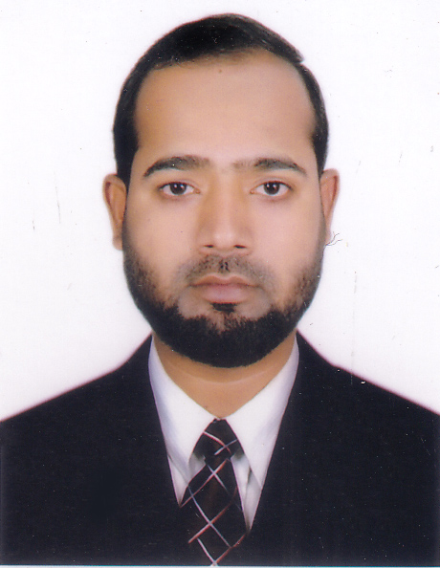
RESUME
Of
MD. RIAZUL ISLAM
Block-B, Road-03, Aftabnagar,
Badda, Dhaka-1212. Cell: 01719-773011
Email: Riaz.mahmud711@gmail.com

]

CAREER OBJECTIVE

Achieving A dynamic challenging Job. To utilize my academic background as well as exercise for the interest of the organization and my career, to work in the environment that involves professional challenges, appreciates hard working and integrity in carrying out responsibilities development interpersonal skills, sharing my knowledge with various professional and build up myself as an expert professional.

EDUCATIONAL QUALIFICATION

SSC
Institution : Biani Bazar Senior Kamil Madrasha
Passing year : 2011
Group : Science
GPA : GPA_5.00
Board : Madraha

HSC
Institution : Rokeya Ahasan College
Passing year : 2014
Group : Science
GPA : GPA_4.10
Board : Dhaka

Hon’s (CSE)
Institution : Sonargaon University
Passing year : 2020
CGPA : CGPA_3.53 (Out of 4.00)
Travelling in long distance and visiting new places, reading books & social work.
HOBBIES & INTEREST

LANGUAGE PROFICIENCY
Bengali : Fluently speaking and writing capabilities.
English : A good skill speaking and writing capabilities.
Arabic : A good skill speaking and writing capabilities.

COMPUTER KNOWLEDGE

MS word, MS Excel, PowerPoint, Email. & Internet, graphics, video editing, web application by PHP with Laravel Framework.

TRINING SUMMARY:
• Training Title 1: Object Oriented Php with Laravel Framework.
• Training Title 2: Advance Ecommerce Project.
• Topic: HTML5, CSS3, Row Php, object oriented php, Laravel framework, MySQL, Java
Script, Ajax.
• Institute: Bangladesh Association of Software & Information Services (BASIS).
• Country: Bangladesh.
• Location: BDBL Bhaban (4th Floor), 12 Kawran Bazar, Dhaka.
• Year: 2023
• Duration 1: 3 month.
• Duration 2: 2 month.

JOB EXPERIENCE
- Inspection, Administration & Re-checker about 01 year of aftabnagar
ideal school & college.
- Inspection, Administration & Coordinator about 02 years of New
Nation ideal school & college.

PERSONAL DETAILS

Name : Md. Riazul Islam
Father’s name : Md. Afsar Uddin
Mother’s Name : Sonaban Begum
Date of Birth : 7th November, 1995
Gender : Male
Religion : Islam (Sunni)
Nationality : Bangladeshi by Birth
Marital Status : Married
Height : 5' 4"
Permanent Address : Vill-Hoglabunia, P.O-Hoglabunia
P.S- Nazirpur, Dist-Pirojpur

I declare that the above information mentioned, to the best of my knowledge is true and correct in every particular.

Signature

Date: ....................

